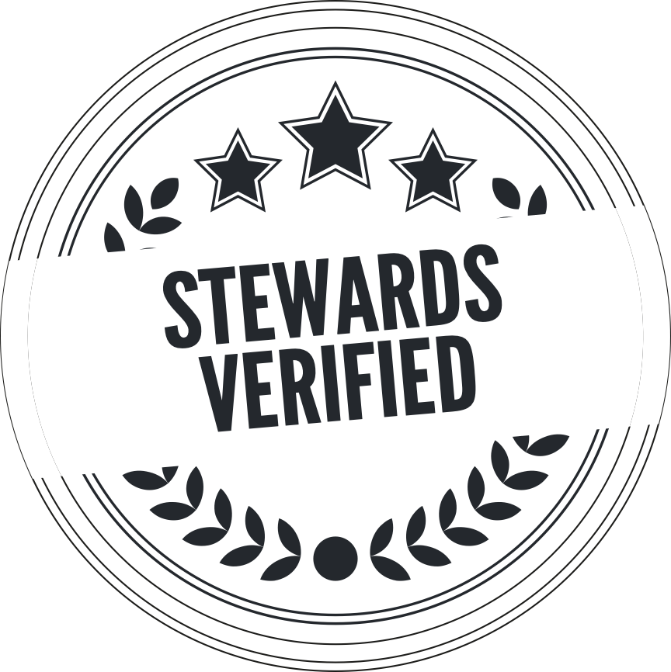

|  |  |  |  |  |  |  |
| --- | --- | --- | --- | --- | --- | --- |
| **NOM DE LA COMPÉTITION** | | | | | | |
| TRACK | | | ROUND | LOBBY | RACE / STINT | DATE |
| CIRCUIT | | | - | A | - | - |
|  | | | **INCIDENT** |  | | |
| **UNDER INVESTIGATION** | | | *N°18-224R4L1-19* | **AFFECTED DRIVER(S)** | | |
| **No / Driver** | **#00 / TAG_PSEUDO** | | VS | **No / Driver** | **#00 / TAG_PSEUDO** | |
| Team competitor | ÉQUIPE | | Team competitor | ÉQUIPE | |
|  |  |  |  |  |  |  |
| **FACT** | Lorem ipsum dolor sit amet, consectetur adipiscing elit. Sed non risus. Suspendisse lectus tortor, dignissim sit amet, adipiscing nec, ultricies sed, dolor. Cras elementum ultrices diam. Maecenas ligula massa, varius a, semper congue, euismod non, mi. Proin porttitor, orci nec nonummy molestie, enim est eleifend mi, non fermentum diam nisl sit amet erat. Duis semper. Duis arcu massa, scelerisque vitae, consequat in, pretium a, enim. Pellentesque congue. | | | | | |
| **CONCLUSION** | Lorem ipsum dolor sit amet, consectetur adipiscing elit. Sed non risus. Suspendisse lectus tortor, dignissim sit amet, adipiscing nec, ultricies sed, dolor. Cras elementum ultrices diam. Maecenas ligula massa, varius a, semper congue, euismod non, mi. Proin porttitor, orci nec nonummy molestie, enim est eleifend mi, non fermentum diam nisl sit amet erat. Duis semper. Duis arcu massa, scelerisque vitae, consequat in, pretium a, enim. Pellentesque congue. | | | | | |
|  | | | | | | |
| **DECISION** | | PENALTY (POINTS) | OFFENCE CATEGORY | BONUS | MSL S.R. |  |
| 1 | 2 | - | - |
| vendredi 22 mars 2024 | | | | | | |